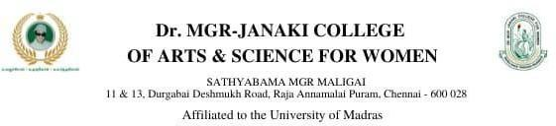

**DEPARTMENT OF MATHEMATICS**

**PROJECT RECORD**

**ON**

**MEASURING THE PUISE OF PROSPERITY AN INDEX OF ECONOMIC FREEDOM ANALYSIS**

* **DATA ANALYTICS WITH TABLEAU**

**TAMILNADU SKILL DEVELOPMENT CORPORATION, GOVERNMENT OF TAMILNADU,**

**NAAN MUDHALVAN PROGRAM**

**Submitted**

**By**

**1.SARANYA.G (222006468)**

**2.PAVITHRA.P (222006462)**

**3.GAYATHRI MALA .S (222006451)**

**4.RATHIMEENA.N (222006466)**

**(III B.sc MATHEMATICS)**

**CERTIFICATE**

THIS IS TO CERTIFY THAT THE PROJECT IS TITLED MEASURING THE PULSE OF PROSPERITY AN INDEX OF ECONOMIC FREEDOM ANALYSIS

THIS PROJECT IS SUBMITTED BY G.SARANYA (222006468) P.PAVITHRA (222006462)…………OF III B.SC MATHEMATICS, Dr.MGR JANAKI COLLEGE OF ARTS AND SCIENCE FOR WOMEN, CHENNAI IN FULFILLMENT OF THE REQUIREMENTS FOR **TAMILNADU SKILL DEVELOPMENT CORPORATION, GOVERNMENT OF TAMILNADU,NAAN MUDHALVAN PROGRAM**. THIS PROJECT WAS AN AUTHENTIC WORK DONE BY HIM UNDER MY SUPERVISION AND GUIDANCE.

TABLE OF CONTENTS;

|  |  |  |
| --- | --- | --- |
| S.NO | CONTENT | PAGE.NO |
| 1 | INDROTUCTION | 4 |
| 2 | PROBLEM DEFINITION AND DESIGN THINKING | 5 |
| 3 | RESULT | 7 |
| 4 | ADVANTAGES AND DISADVANTAGES | 11 |
| 5 | APPLCATIONS | 12 |
| 6 | CONCLUSION | 13 |
| 7 | FUTURE SCOPE | 14 |
| 8 | VIDEO LINK | 14 |

MEASURING THE PULSE OF PROSPERITY AN INDEX OF ECONOMIC FREEDOM ANALYSIS.

1.INTRODUCTION;

1.1.Overview;

On march 23,2020 the index of economic freedom 2020 was released where india was ranked 120th out of 186 countries.The index was created in 1995 by The Heritage foundation and The wall street journal and it aims to measure the level of economic freedom in the world’s nations.The Heritage Foundation a us conservative think tank,recently launched the “Economic Freedom Index”.In the index ,Singapore has topped the gobal ranking for the second consecutive year.The overall score of the Singapore was increased by 0.3 points to 89.7.The index was Prepared by covering 184 countries this time for the period of July 2019 to June 2020.India has obtained a score of 56.5 this year which is ranked at the middle among Asia Pasific countries that is 26th out of 40 Asia Pacific countries.

1.2.Purpose;

Economic freedom is the Fundamental right og every human to control his or her own labor and property.In an economically free society individuals are free to work ,produce ,consume, and invest in any way they please.Economic freedom brings greater prosperity .The index of economic freedom documents the positive relationship between economic freedom and a variety of positive social and economic goals.The ideas of economic freedom are strongly associated with healthier societies ,cleaner ,environments ,greater per capita wealth ,human ,development,democracy,and poverty elimination.

2.PROBLEM DEFINITION & DESIGN THINKING;

2.2.Empathy map;

An empathy map is a collaboratia tool teams can use to gain a deeper insight into their customers.Much like a user personal an empathy map can represent a group of users such as a customer segment.The empathy map was originally created by Dave Gray and has gained much popularity within the agile community.

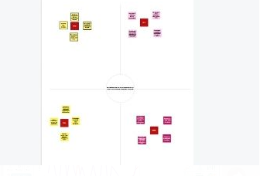

2.2.Ideation &Brainstorming Map;

Ideation is often closely related to the practice of brainstorming , a specific technique that is utilized to generate new ideas.A principal difference between ideation is commonly more thought of as being an individual pursuit,while brainstorming is almost always a group activity.

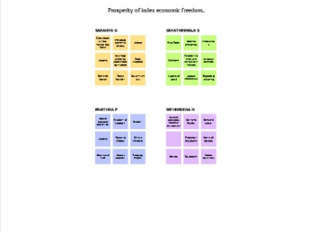

3.RESULT;

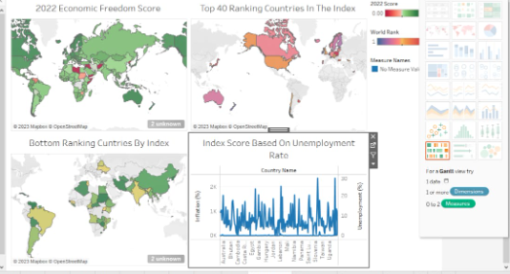

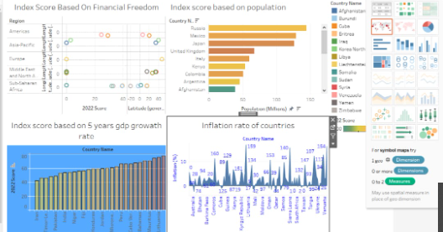

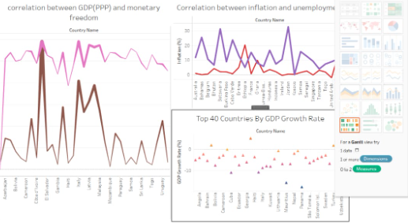

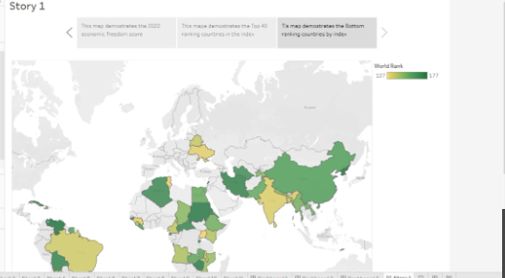

4.ADVANTAGES & DISADVANDAGES;

For businesses the main advantage of a free market economy is the absence of bureaucracy and red tape.This reduces administrative costs to the business;money which the company can put into other endeavors such as research and development.Freedom market economies allow business owners to innovate new ideas develope new products and offer new services. Entrepreneurs need not depend on government agencies to tell them when the public needs a new product.They can study consumer demands research popular trends and meet the customers needs through innovation.Innovation also breeds competition among firms as each firm attempts to improve on the previous product generations by adding more and better features to existing products.

MARKET FAILURES;When a free market economy spins out of control the consequences can be serve.From the great depression of the 1930s to the real estate market crash of 2008,market failures have devasted the lives of millions In lost income unemployment and homelessness.Many of these failures have stemmed from those seeking short term profits over slow and steady gains usually aided by loose credit highly leveraged assets and minimal government intervention.The primary objective for any company in a free market economy is to make a profit.In many cases companies may sacrifice worker safety environmental standards and ehical behaviour to achieve those profits.The early 2000s saw such unethical behaviour run rampant at companies such as enron and worldcom.The deepwater Horizon oil spill in 2010 one of the largest environmental disasters in US.History was largely attributable to the use of substandard cement and other cost cutting measures.

5.APPLICATION;

It is an annual index and ranking.It was created in the year 1995 by the conservative think tank called the Heritage foundation and The wall street journal.This index measures the degrees of economic freedom among the world’s nations.This index is inspired by Adam Smith’s approach in the wealth of nations which states that the ‘basic institutions which protect the liberty of indivituals to pursue their economic interests in turn result into the greater properity for bigger society.

6.CONCLUSION;

The foundation remarked that over the past 5 years India experiences strong GDP growth.But the country needs to take the steps to improve fiscal health address the shortcomings in banking regulations start privatizing state owned banks to increase financial independence and make reforms in tax code investment regime and labour code.

7.FUTURE SCOPE;

Areas that development economics focuses on include health ,education,working,conditions,and market conditions.Developement economics seeks to understand and shape macro and microeconomic policies in order to lift poor countries out of poverty.Growth in advanced economics is expected to decline from 5 percent in 2021 to 3.8 percent in 2022 and 2.3 percent in 2023 a pace that while moderating to their pre pandemic trend in these economics.

8.VIDEO LINK;

https://drive.google.com/file/d/1rQ8wcPVggQq3lrZUSieM2x5Bw3mXn2NH/view?usp=drivesdk